**Elementary Lunch Menu**

**June 2nd-11th**

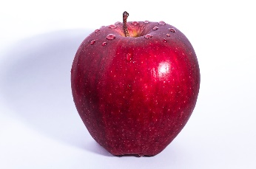

Monday, June 2nd

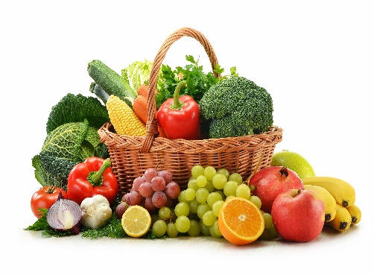 Cheesy Penne Pasta

w/ Garlic Bread/Biscuit/Breadstick

Tuesday, June 3rd

Taco in a Boat

Wednesday, June 4th

Cheeseburger

Thursday, June 5th

Popcorn Chicken w/ Garlic Bread/Biscuit/Breadstick

Potatoes

Friday, June 6th

Domino’s Day

Monday, Tuesday and Wednesday, June 9th, June 10th and 11th

Chef’s Choice

**All lunches are served with vegetables, fruit and milk**

**Menu subject to change**

Jennifer M. Mullin, SNS Washington TWP Food Service Manager 856-582-4010 Have a great summer!!

Please look for the 2025-2026 SCHOOL MEAL AND S-EBT APPLICATION coming out soon.